Expleo Challenging DOM

System Test Plan

Prepared By
Naveen Kumar Baddam

This document specifies the Test Plan of Challenging Dom project which contains all the information about Tools, Automation Test Cases of the application and environment setup to be followed.

Table of Contents

1.0 Project History

Version | Designed Date | Name | Modification Summary
1.0 | 04/08/2021 | Naveen Baddam | Initial Challenging DOM Page

2.0 Approvals

Name | Emp Id | Role | Date
ExpleoGroup |  | Manager

3.0 Test Team

Name | Role | Tasks | Comments
Name1 | Test Lead | All Lead Activities
Name2 | QA Automation | Automation Activities
Name3 | QA Manual | Manual Testing Activities

4.0 Test Cases

Testcase  ID | Testcase Name | Expected | Actual
TC_001 | Verify_ChallengingDOM_PageTitle | “The Internet” | “The Internet”
TC_002 | Verify_ChallengingDOM_  Header | “Challenging DOM” | “Challenging DOM”
TC_003 | Verify_ChallengingDOM_PageDescription | “Description” | “Description”
TC_004 | Verify_ChallengingDOM_  FooterText | “Powered by Elemental  Selenium” | “Powered by Elemental  Selenium”
TC_005 | Verify_ChallengingDOM_  FooterLink | “elementalselenium.com” | “elementalselenium.com”
TC_006 | Verify_PorkMeGitHUB_ Link | Should navigate to GitHub link | Navigated to GitHub Link
TC_007 | Verify_Canvas | Canvas should be present on the page | Canvas presented on the page
TC_008 | Verify_TableHeadersList | Should re return list of headers | Returned list
TC_009 | Verify_Table_Size | Should return the table  Size Ten | Return the table  Size as Ten
TC_010 | Verify_EditLinkPresent_  At_All_Rows | Edit should be present in each row of table | Edit presented in each row of table
TC_011 | Verify_DeleteLinkPresent_At_All_Rows | Delete should be present at each row of table | Delete presented at each row of table

5.0 Test Environment Tools
The following list of software will be required in the System Test Environment

QA URL | Challenging DOM “http://<app-server>”
Browser Drivers | Gecko driver, Chrome driver, IE driver
Programming Language | Java
Operating System | Windows
Tools | Selenium, TestNG, Maven, Git, Jenkins, Selenium Grid
IDE | Eclipse
Build tool | Maven
CI/CD | Jenkins
VCS | Git

6.0 Environment Setup and Test Execution
- Install Eclipse to write Selenium automation Test Scripts
- Install Java to enhance the selenium Test Cases
- Create Maven Project in Eclipse and add all project dependencies to the pom.xml
- Download related browser drivers add them to the project
- Setup Remote Environments for Cross Browser Testing by using Selenium Grid
- Use GitHub as a version control tool
- Configure Job in Jenkins CI/CD to execute the project by using Git
- Analyze Test Summary Reports

7.0 Project Dependencies
- Selenium-Server_Standalone Software(Web)
- TestNG (TestCases, Reports)
- Browser Drivers (Gecko Driver, Chrome Driver)
- Log4J (Logs)
- Maven (Build)
- Apache POI
- Commons-IO (File Utilities)

8.0 Defect Tracking
The following use case shows the defect tracking process (ex: Jira)

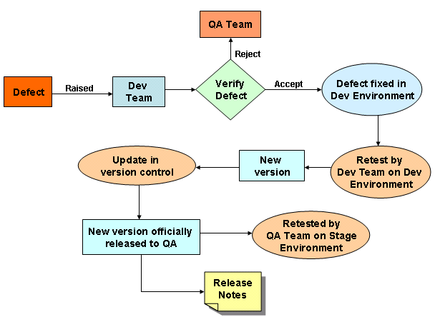

9.0 Test Deliverables
- Test Plan Document
- Test Design Docs
- Test Case Docs
- Test Environment Reports
- Bug Reporting Docs
- Test Results Docs
- Test Exit Criteria Docs

